Income Statement
An income statement, also known as a profit and loss statement, is a financial report that summarizes a company’s revenues and expenses over a specific period of time, typically a quarter or a year.
The income statement, or profit and loss statement, is one of the main financial statements of a business that shows its profit or loss for a specific period. Public companies operating in the United States are required by law to provide their income statement at the end of every quarter and fiscal year.
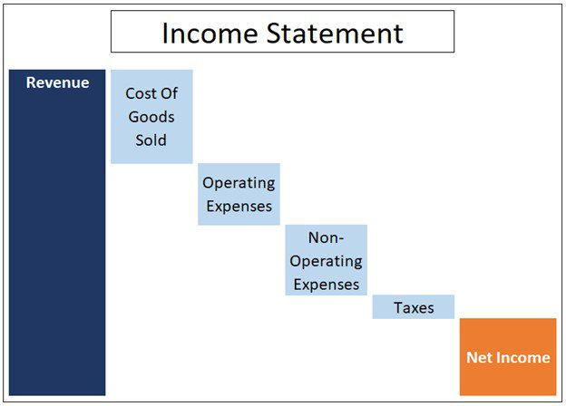

Components of an Income Statement
- Revenue: The amount of money a business takes in during a reporting period
- Expenses: The amount of money a business spends during a reporting period
- Costs of goods sold (COGS): The cost of component parts of what it takes to make whatever it is a business sells
- Gross profit: Total revenue less COGS
- Operating income: Gross profit less operating expenses
- Income before taxes: Operating income less non-operating expenses
- Net income: Income before taxes less taxes
- Earnings per share (EPS): Division of net income by the total number of outstanding shares
- Depreciation: The extent to which assets (for example, aging equipment) have lost value over time
- EBITDA: Earnings before interest, depreciation, taxes, and amortization

Importance of income statements
Understanding the significance of income statements in accounting is crucial for evaluating a company's financial health. Here are the key points:
  - Performance Measurement: Income statements provide a clear view of a company's profitability over a specific period.
  - Revenue Tracking: They detail revenue sources, helping identify which products or services are most profitable.
  - Expense Management: Income statements outline expenses, allowing businesses to control costs and improve efficiency.
  - Investment Decisions: Investors use income statements to assess a company's financial viability and make informed investment choices.
  - Trend Analysis: They enable comparison of financial performance over different periods, highlighting growth or decline trends.
  - Tax Reporting: Income statements are essential for calculating taxable income and ensuring compliance with tax regulations.
  - Budgeting and Forecasting: They assist in creating budgets and financial forecasts based on historical performance.
  - Stakeholder Communication: Income statements serve as a communication tool for stakeholders, including shareholders and creditors, about financial results.
  - Regulatory Compliance: They help companies meet legal and regulatory requirements for financial reporting.
  - Strategic Planning: Income statements inform strategic decisions by providing insights into operational efficiency and profitability.

Limitations of income statement
When examining the limitations of an income statement, consider the following points:
- Non-Cash Items: Income statements include non-cash items like depreciation, which can distort actual cash flow.
- Historical Data: They reflect past performance and may not accurately predict future profitability.
- Accounting Methods: Different accounting methods (e.g., cash vs. accrual) can lead to varying results.
- Omissions: Certain expenses, like opportunity costs, are not recorded, potentially misleading stakeholders.
- One-Time Events: Income statements may include one-time gains or losses that do not reflect ongoing operations.
- Lack of Context: They do not provide insights into the company's overall financial health or market conditions.
- Comparability Issues: Variations in industry practices can make comparisons between companies difficult.
- Focus on Profitability: They prioritize profitability over other important metrics like liquidity and solvency.
- Subjectivity: Estimates and judgments in reporting can introduce bias and affect reliability.
- Limited Scope: They do not capture all aspects of business performance, such as customer satisfaction or employee engagement.

Example #1

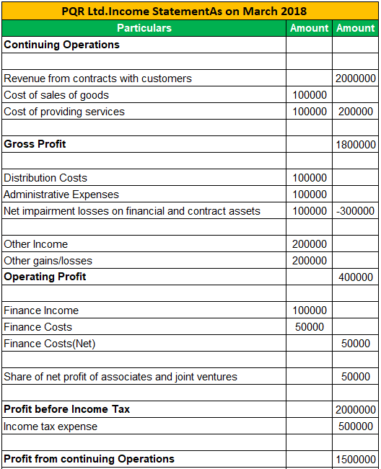

Current Liabilities

Current Liabilities
Current liability is a financial obligation a company must settle within one year, including debts like accounts payable, short-term loans, and accrued expenses. These liabilities are crucial for assessing a company’s short-term financial health and liquidity.
Current liabilities are a company's short-term financial obligations, or debts that are expected to be paid within one year.
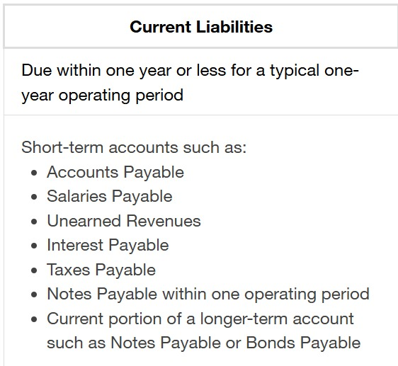

Current Liabilities Formula
Current Liabilities = Accounts Payable + Short-Term Loans + Accrued Expenses + Deferred Revenue + Current Portion of Long-Term Debt + Other Current Liabilities.
Types of Current Liabilities
- Accounts Payable: Money owed to suppliers for goods or services received on credit.
- Short-Term Loans: Loans and other borrowings that are due for repayment within one year.
- Accrued Expenses: Expenses that have been incurred but not yet paid by the end of the accounting period.
- Deferred/ Unearned Revenues: Payments received in advance for goods or services to be delivered in the future.
- Notes Payable: Written promises to pay a certain amount of money by a specific date, usually within one year.
- Dividends Payable: Dividends that have been declared but not yet paid to shareholders. The amount of money a company owes to its shareholders.
- Income Taxes Payable: Taxes owed to the government that must be paid within the next year.
- Sales Taxes Payable: Sales taxes collected from customers that must be remitted to the government.
- Wages Payable: Wages earned by employees but not yet paid by the end of the accounting period.
- Bank account overdrafts: Fees that accrue when a bank account is overdrawn
- Customer deposits: Money received for services or products that have not yet been delivered.
- Interest payable: Interest that has accrued during an operating period but has not yet been paid.

Difference between Liabilities and Current Liabilities

Aspect | Liabilities | Current Liabilities
Definition | Liabilities are all financial obligations a company owes to others, including both short-term and long-term debts. | Current liabilities are short-term financial obligations that a company must settle within one year.
Duration | Includes both short-term (due within one year) and long-term obligations (due after one year). | Specifically includes only those obligations that are due within one year.
Examples | Long-term loans, bonds payable, deferred tax liabilities, pension obligations. | Accounts payable, short-term loans, accrued expenses, deferred revenue, current portion of long-term debt, taxes payable.
Impact on Balance Sheet | Appears as a total figure on the balance sheet, categorized into current and non-current liabilities. | Appears under the current liabilities section on the balance sheet.
Financial Analysis | Used to assess overall financial health, leverage, and long-term solvency of the company. | Focused on evaluating the company’s short-term liquidity and ability to meet immediate financial obligations.

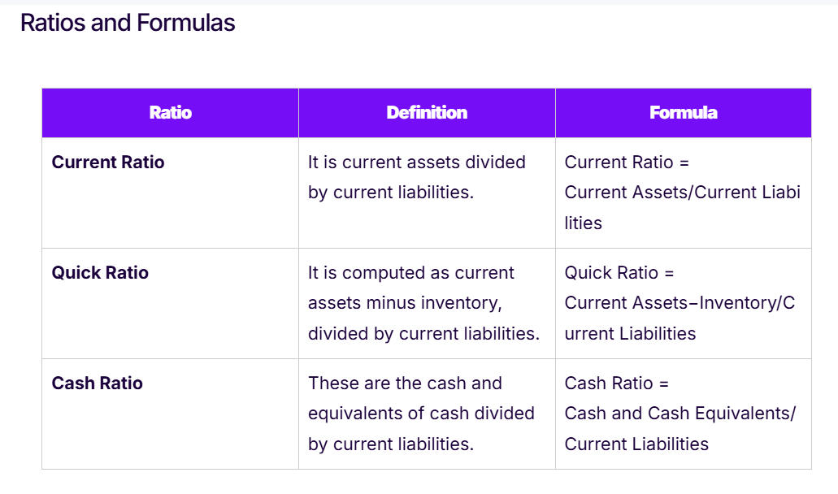

What is a statement of retained earnings?
A statement of retained earnings shows changes in retained earnings over time, typically one year. Retained earnings are profits not paid out to shareholders as dividends; that is, they are the profits the company has retained. Retained earnings increase when profits increase; they fall when profits fall.
The statement of retained earnings is also called a statement of shareholders’ equity or a statement of owner’s equity.
Uses of Retained Earnings
Retained earnings are the profits that the company keeps for use internally or for when a need arises. The profits may be reinvested into certain revenue-generating activities of the company or used to make debt repayments. Other possible uses of retained earnings include:
- Expansion: The Company may use the retained earnings to fund an expansion of its operations. The funds may go into building a new plant, upgrading the current infrastructure, or hiring more staff to support the expansion.
- New product launch: A company may also use the retained earnings to finance a new product launch to increase the company’s list of product offerings. For example, a beverage processing company may introduce a new flavor or launch a completely different product that boosts its competitive position in the marketplace.
- Dividend payments: The surplus can be distributed to the company’s shareholders according to the number of shares they own in the company.
- Merger or acquisition: During the growth phase of the business, the management may be seeking new strategic partnerships that will increase the company’s dominance and control in the market.

Example-1:
Supreme Ltd retained earnings of $ 38000 on January 1, 2025. The company reported a net income of $ 164000 for the year. The company, looking at good net income for the year, decided to pay a stock dividend of 10% on 10000 common shares when the shares were trading at $ 14 per share in the market.
Answer:
Retained Earnings on December 31, 2025 = Retained Earnings on January 1, 2025 + Net Income – Stock Dividends Paid
= 38000 + 164000 – (0.10 x 10000 x 14)
= 38000 + 164000 -14000
= $ 188,000

Example-1
Chan Ltd started 2015 with an opening retained earnings balance of $2,340. It earned a net income of $14,890 during the year and paid a dividend to preferred shareholders amounting to $4,210 and the equity shareholders worth $3,640. There was also a prior period adjustment of $2,400. The retained earnings at the end of the year 2015 will be calculated as below:
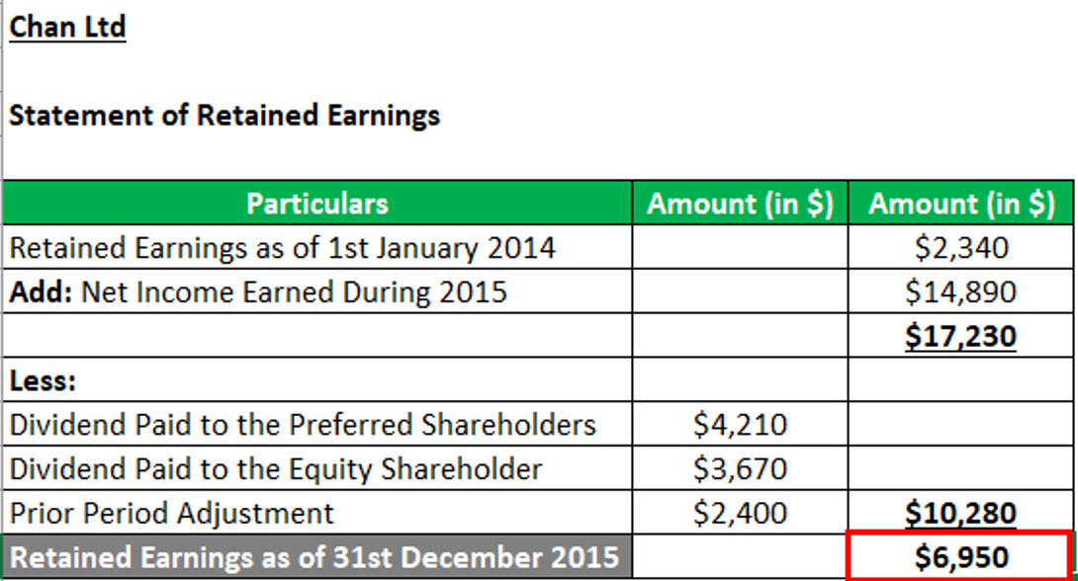

Statement of Cash Flows
A cash flow statement (CFS) is a financial statement primarily intended to provide information about the cash receipts and cash payments of a business during the period of time covered by the income statement.
The statement of cash flows (also referred to as the cash flow statement) is one of the three key financial statements. The cash flow statement reports the cash generated and spent during a specific period of time (e.g., a month, quarter, or year). The statement of cash flows acts as a bridge between the income statement and balance sheet by showing how cash moved in and out of the business. The three sections of the cash flow statement are: operating activities, investing activities and financing activities.
Objectives of the Cash Flow Statement
The main objectives of the cash flow statement are to provide information and knowledge about the following key areas:
- Knowledge of cash inflows and outflows: The cash flow statement shows the various sources of cash inflow into the businesses, as well as where cash has been applied.
- Knowledge of trading profits: The statement offers insights into how cash is generated and where it is being used, as well as what the balance is and whether it is in excess or not.
- Knowledge of increase or decrease in share capital: The cash flow statement highlights the changes in share capital (whether it has increased or decreased).
- Knowledge of purchase or sale of fixed assets: The statement provides useful information about the purchase or sale of fixed assets.
- Knowledge of increase or decrease in long-term loans: The statement shows why long-term loans were raised or, if a loan is paid, what the source of the payment was.
- Knowledge of increase or decrease in cash balance: The statement highlights the exact position of whether the cash in the business has increased or decreased over a specific period.
- Knowledge of tax and dividends paid: This statement is useful in helping to learn about the amount that a business usually pays for taxes and dividends.

    - Showing the Inflows and Outflows (sources and applications) of cash into/out of the business during a specific period.
    - Disclosing the 'Positive' and 'Negative features of 'Cash Management' undertaken by the organization.
    - Facilitating the policy formulation by the management in respect of certain financial matters such as Dividend Policy.
    - Ascertaining the Liquidity Position of the business organization.
    - Finding out the net changes having taken place in respect of 'Cash' and 'Cash Equivalents'.
    - Studying the trend regarding 'Cash Receipts' and 'Cash Payments'.
    - Finding out the 'Deviation of Cash' from 'Earnings'.
    - Assessing the Financial Position of the business enterprise in a more realistic manner and forecasting the 'Cash Position'.

Purpose of Cash Flow Statement
Let’s look at the purpose of cash flow statement:
- Cash flow statement helps in identifying the sources of cash inflow and whether or not it’s utilized within a specific period of time
- It’s significant for proper planning and management of cash and maintaining a balance between cash inflow and outflow
- Investors get to easily spot the efficiency, or the lack of it, with which a business generates its cash flow
- Appraisal of capital investment programs is done with the help of a cash flow statement, which determines their viability and profitability
- It enables assessment of net assets and other financial reports
- It’s essential for stabilizing and optimizing an organization’s cash flow
- It determines the overall health of a business and allows investors, creditors and shareholders to determine its financial reliability and efficiency to pay for operational expenses

Importance of Cash Flow Statement
The cash flow statement provides information regarding inflows and outflows of cash of an organization for a particular period. Therefore, we say that the following are the importance of cash flow statement:
- The cash flow statement helps to identify the sources from where cash inflows have arisen and where in the cash was utilized within a particular period.
- The cash flow statement is significant to management for proper cash planning and maintaining a proper matching between cash inflows and outflows.
- The cash flow statement shows the efficiency of a firm in generating cash inflows from its regular operations.
- The cash flow statement reports the amount of cash used during the period in various long-term investing activities, such as the purchase of fixed assets.
- The cash flow statement reports the amount of cash received during the period through various financing activities, such as the issue of shares, debentures, and raising long-term loans.
- Cash flow statement helps for appraisal of various capital investment programs to determine their profitability and viability.
- A cash flow statement helps investors to judge whether the company is financially sound or not.
Difference between Cash Flow and Fund Flow Statement :
Basis | Fund Flow Statement | Cash Flow Statement
Nature of Statement | It states the changes in working capital. | It states the changes in cash position.
Object | The objective of preparing fund Flow Statement is to gather information with regard to an enterprise ability to meet its long term liabilities. | The objective of preparing cash flow statement is to gather information with regard to an enterprise ability to meet its short term liabilities.
Opening Balance | There is opening balance of cash in hand in the preparation of fund flow statement. | It is prepared with opening balance of cash in hand.
Period | Preparation of fund flow statement is for a longer period. | Preparation of cash flow statement is for a shorter period.
Planning | Fund flow statement facilitates long term planning of an enterprise. | Cash flow statement facilitates short term planning of the enterprise.
Dependence | Funds Flow Statement can be prepared with the help of cash flow statement. | Cash flow statement can't be prepared with the help of fund flow statement only.
Additional Statement | Preparation of fund flow statement is necessary followed by the preparation of an additional statement. | Preparation of cash flow statement is not followed by the preparation of any additional statement.
Difference of Sides | Difference between both the sides of fund flow statement is either in increase or decrease in working capital. | Difference between both the sides of cash flow statement is the closing balance of cash.

Advantages of Cash Flow Statement:

Preparation and analysis of cash flow statement have the following advantages:

1) It facilitates measurement of the business enterprise's ability to meet its fixed charges.
2) It is useful in bringing to the forefront the business enterprise's status with regard to its ‘Liquidity' and 'Solvency' during adverse conditions.
3) It is helpful in assessing the changes in 'Cash Position' between 'Profit & Loss Account' and 'Balance Sheet' items of two consecutive accounting periods.

4) Disclosures made by the 'Cash Flow Statement enables the management of a business enterprise to initiate preventive measures in financially difficult situations.

5) Identification of 'Discretionary Cash Flows' from business transactions becomes possible through 'Cash Flow Analysis'.

6) It facilitates listing out the 'Potential Financial Flows', which may be put to use during crisis conditions.
7) Cash Flow Statement reveals the information with regard to the availability of 'Cash'. Such information is very useful in deciding the quantum of 'Dividend' to be distributed to the shareholders or in extreme cases whether or not to skip a dividend payment altogether.

Disadvantages of Cash Flow Statement :
Cash flow statement is deficient in certain respects, some of which are as follows:
1) Non-Cash Transactions are overlooked:
The entire focus of Cash Flow Statement is exclusively on the 'Inflows' and 'Outflows of cash. Non-Cash Transactions' like purchase of buildings by issuing shares/debentures to the vendors or issue of bonus shares are out of its purview.
2) Not a Substitute for an Income Statement:
An 'Income Statement' of a business organization covers both 'Cash' and 'Non-Cash' items and reveals the 'Net Income'. 'Cash Flow Statement, on the other hand, takes into consideration only 'Cash Flows' and as such can show only 'Net Cash Flows' inflows or outflows. It cannot disclose the 'Net Profit/Loss' of the organization.

3) Limited Use:
'Cash Flow Statement' has very limited use in isolation. Only when it is accompanied by other 'Financial Statements' like 'Balance Sheet' and 'Profit & Loss Account', it provides some meaningful and useful results.

4) Historical in Nature:
Preparation of 'Cash Flow Statement' involves rearranging other Financial Statements, viz. 'Balance Sheet' and 'Profit & Loss Account, which contain past data and are historical in nature. It would have been more useful and prospective in nature, when accompanied with 'Projected Cash Flow Statement'.

5) Ignoring the Accrual Concept:
Accrual concept, one of the basic accounting concepts, is totally ignored while preparing cash flow statement.

Steps to Prepare the Cash Flow Statement
The procedure is the same as with a fund flow statement. The left-hand side records various sources of cash inflows and the right-hand side records the use or outflows of cash.
1. Cash inflows: Opening cash, cash from operations, issue of share capital, issue of debentures, issue of long-term loans, sales of fixed assets, and capital profits (profit on the sale of fixed assets)
2. Cash outflows: Cash lost in operations, redemption of preference shares, redemption of debentures, repayment of long-term loans, purchase of fixed assets for cash, and payment of liabilities.

Format/Specimen of Cash Flow Statement

Cash Inflow | Amount | Cash Outflow | Amount
1. Opening cash | xxxx | Payment of:
2. Cash from operations | xxxx | 1. Dividends | xxxx
3. Long-term loans | xxxx | 2. Tax | xxxx
4. Increase in share capital | xxxx | 3. Long-term loans | xxxx
5. Sale of fixed assets | xxxx | 4. Decrease in preference share capital | xxxx
6. Issue of debentures | xxxx | 5. Fixed assets purchase | xxxx
 |  | 6. Redemptions of debentures | xxxx
 |  | 7. Cash closing balance | xxxx

Format of Cash Flow Statement Preparation (Indirect Method) :

Cash Flow Statement
(for the period ended 31st March.....)
Particulars | Rs.
Cash Flows from Operating Activities
Net Profit as per P&L A/c
Add: Non-Operating Items:
Depreciation on Building
Depreciation on Machinery
Depreciation on Machinery sold
Increase in Provision for doubtful debts
Dividend paid
Transfer to Reserves
Goodwill written off
Preliminary Expenses written-off
Other tangible assets written-off
Loss on sale or disposable of fixed
assets
Less: Profit on sale of investment
Profit on sale of machinery
Operating Profit before Working Capital
Changes
Add: Increase in Current liabilities
Decrease in Current assets
Less: Increase in Current assets
Decrease in Current liabilities
Cash Generated from Operating Activities
Less: Income tax Paid
Net Cash Flows from Operating Activities (A)
Cash Flows from Investing Activities:
Add: Sale of Investments
Sale of Machine
Less: Purchase of Buildings
Less: Purchase of Machinery
Net Cash Flows from Investing Activities (B)
Cash Flows from Financing Activities:
Add: Issue of Share
Add: Issue of Debenture
Less: Redemption of Debentures
Less: Interim Dividend Paid
Less: Dividend Paid
Net Cash Flows from Financing Activities (C)
Net Increase/Decrease in Cash & Cash
Equivalents (A + B+C)
Cash& Cash Equivalents at the Beginning of the Year
Cash &Cash Equivalents at End of the Year

Note : In order to judge the accuracy of cash flow statement (indirect method) one has to examine that net increase/decrease in cash & cash equivalents (A+B+C) and cash & cash equivalents at the beginning of the year must be equal to cash & cash equivalents at end of the year. This can be written as,

Cash & Cash Equivalents at the, end of the year = Net Increase/Decrease in Cash & Cash Equivalents + Cash & Cash Equivalents at the beginning of the year.

Problem 1:
From the following balance sheets of Tarun Ltd., prepare the cash flow statement.

Liabilities | Tk (31.12.2015) | Tk (31.12.2016)
Equity Share Capital | 2,00,000 | 2,50,000
12% Preference Share Capital | 50,000 | 40,000
General Reserve | 35,000 | 55,000
P & L A/C | 15,000 | 17,000
Creditors | 23,000 | 5000
 | 3,23,000 | 3,67,000
Assets
Goodwill | 30,000 | 20,000
Building | 1,00,000 | 80,000
Plant | 40,000 | 70,000
Debtors | 1,20,000 | 1,60,000
Stock | 18,000 | 20,000
Cash | 15,000 | 17,000
 | 3,23,000 | 3,67,000

Adjustments:
i) Depreciation charged on Plant was Rs.30,000.
ii) Depreciation charged on building was Rs.50,000.
Solution:
Cash Flow Statement
(For the period ended 2016)
Particulars | Tk
Cash Flows from Operating Activities:  Net Profit as per P&L AC 17,000 - 15,000)  Add: Non-Operating Items:  Depreciation on Plant 30,000  Depreciation on Building 50,000  Goodwill written-off 10,000  Transfer to General Reserve 20,000  Operating Profit before Working Capital Changes  Less: Decrease in Creditors (18,000)  Increase in Debtors (40,000)  Increase in Stock (2,000)  Net Cash Flows from Operating Activities (A)  Cash Flows from Investing Activities:  Less: Purchase of Building (30,000)  Purchase of Plant (60,000)  Net Cash Flows from Investing activities (B)  Cash Flows from Financing Activities:  Add: Issue of shares (equity) 50,000  Less: Redemption of preference shares (10,000)  Net Cash Flows from Financing Activities (C)  Net increase in Cash & Cash Equivalents (A+B+C)  Cash & Cash Equivalents at the Beginning of the Year  Cash & Cash Equivalents at End of the Year | 2,000  1,10,000
1,12,000

(60,000)
52,000

(90,000)
(38,000)

40,000
2,000
15,000
 | 17,000
Note:
Purchase of Building (80,000 + 50,000) - 1, 00,000 = 30,000
Purchase of Plant (70,000+ 30,000) - 40,000 = 60,000

Problem 2:
Prepare Cash Flow Statement of Suryan Ltd. from the following:
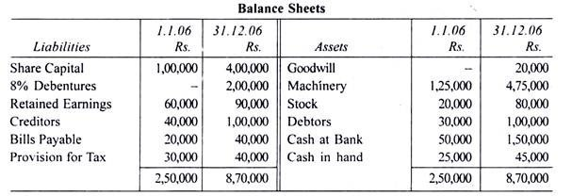
Additional Information:
(a) During 2006, the business of a sole trader was purchased by issuing shares for Rs. 2, 00,000. The assets acquired from him were: Goodwill Rs. 20,000, Machinery Rs. 1, 00,000, Stock Rs. 50,000 and Debtors Rs. 30,000.
(b) Provision for tax charged in 2006 was Rs. 35,000.
(c) The debentures were issued at a premium of 5% which is included in the retained earnings.
(d) Depreciation charged on machinery was Rs. 30,000.
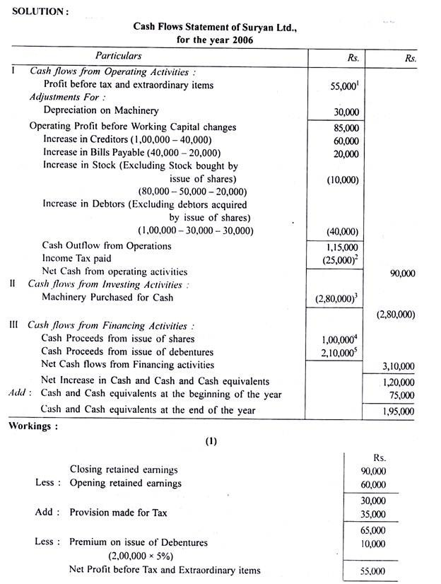

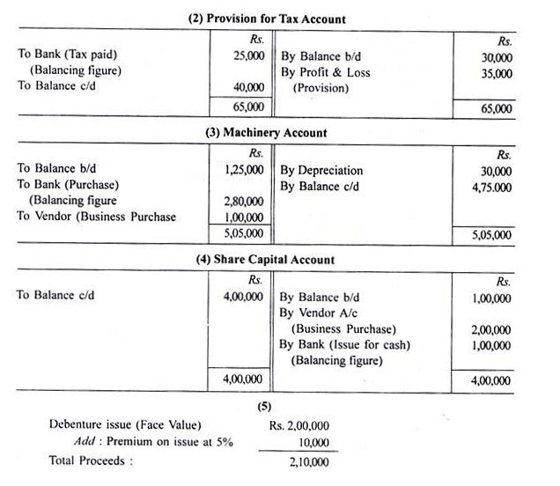

Illustration 1:
Prepare a Cash Flow Statement of Gaurav Ltd. on the basis of the information given in the Balance Sheet:

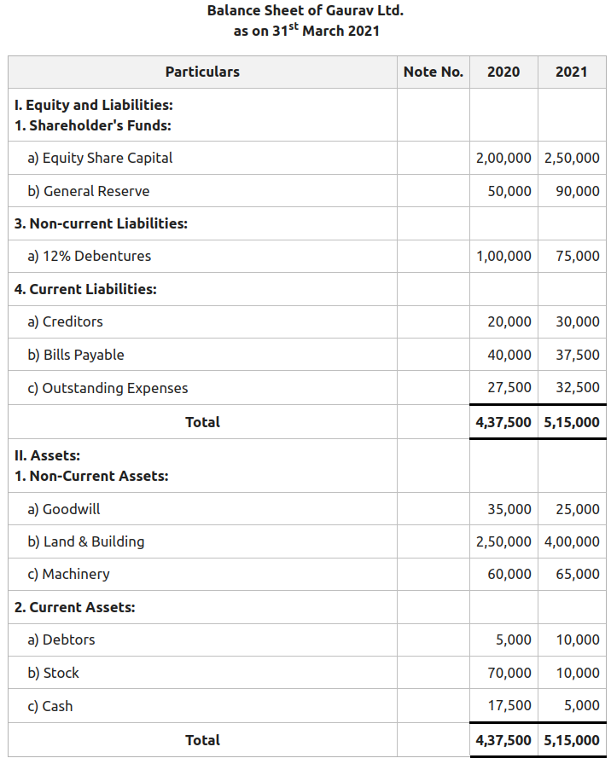

Solution:
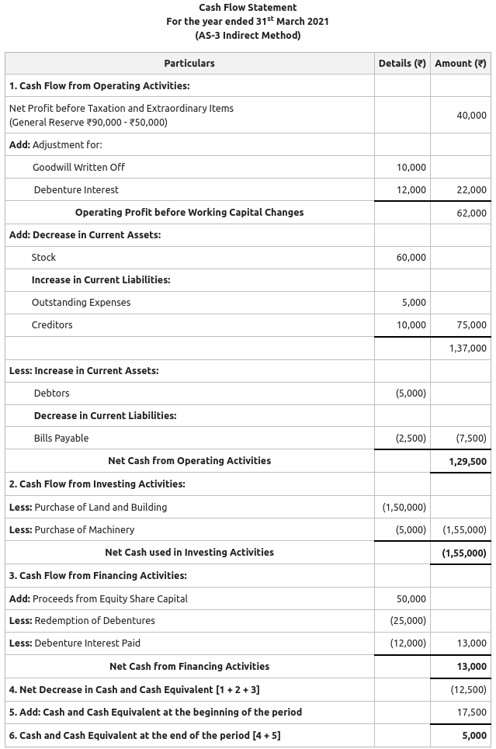
Income Statement Math
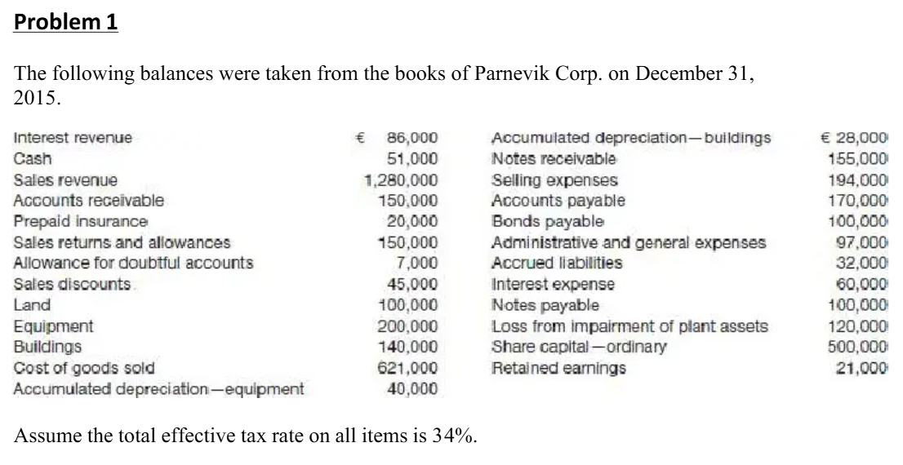
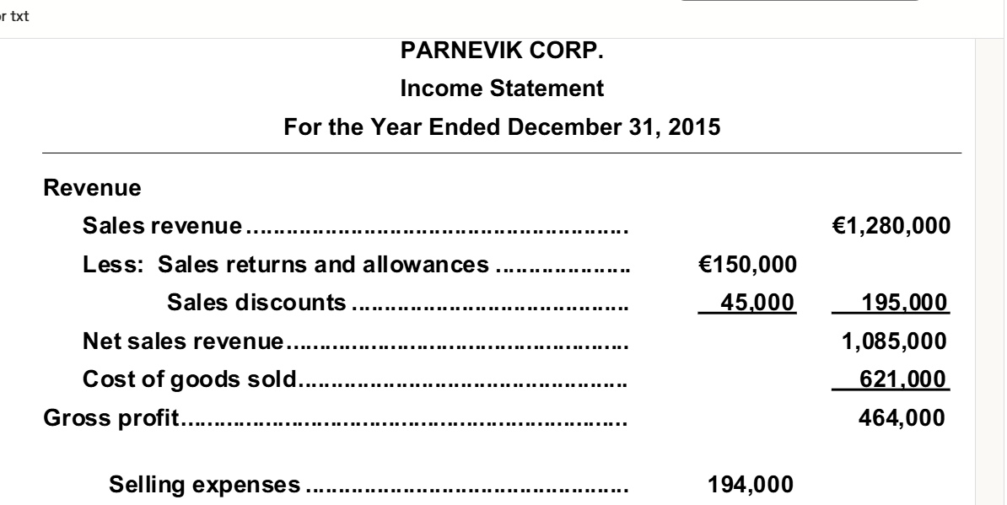
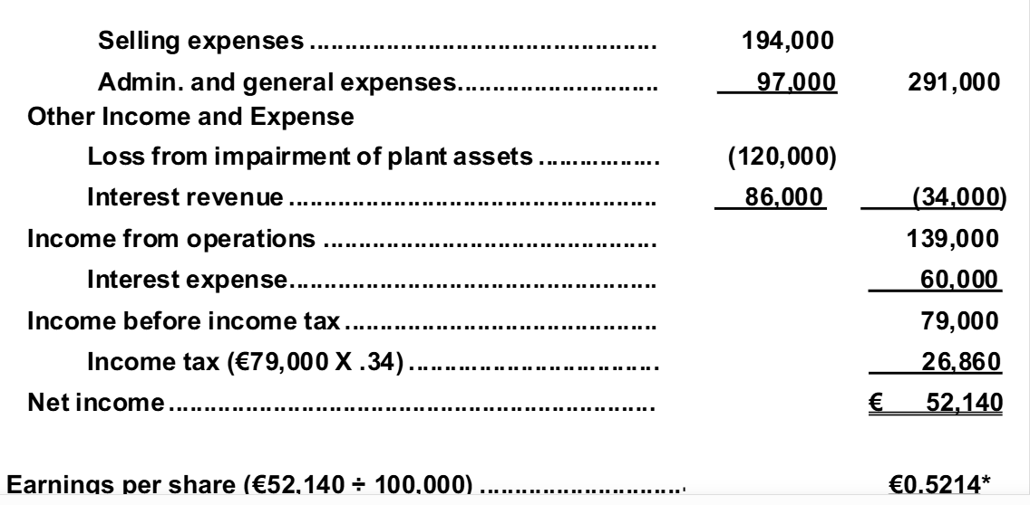

Problem: 2
The accountant of Weatherspoon Shoe Co. has compiled the following information from the company's records as a basis for an income statement for the year ended December 31, 2015.
Rent revenue | 29,000
Interest expense | 18,000
Unrealized gain on non-trading equity securities, net of tax | 31,000
Selling expenses | 140,000
Income tax | 30,600
Administrative expenses | 181,000
Cost of goods sold | 516,000
Net sales | 980,000
Cash dividends declared | 16,000
Loss on sale of plant assets | 15,000
There were 20,000 ordinary shares outstanding during the year.
Required:
Prepare a comprehensive income statement using the combined statement approach.

WEATHERSPOON SHOE CO.
Statement of Comprehensive Income
For the Year Ended December 31, 2015

Particulars | Tk | Tk
Net sales |  | 980,000
Less: Cost of goods sold |  | (516,000)
Gross profit |  | 464,000
Selling expenses | 140,000
Administrative expenses | 181,000 | (321,000)
 |  | 143,000
Other income and expense:
Rent revenue | 29,000
Loss on sale of plant assets | (15,000) | 14,000
Income from operations |  | 157,000
Interest expense |  | (18,000)
Income before income tax |  | 139,000
Income tax |  | (30,600)
Net income |  | 108,400
Other Comprehensive income:
Unrealized gain on securities, net of tax |  | 31,000
Comprehensive income |  | 139,400
Earnings per share (108,400 ÷ 20,000) |  | 5.42

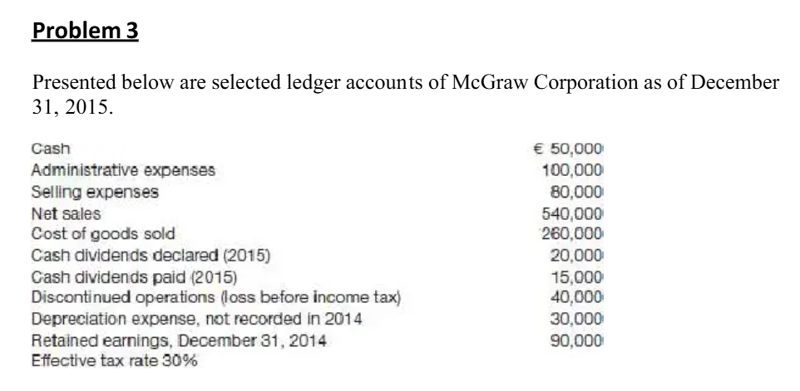
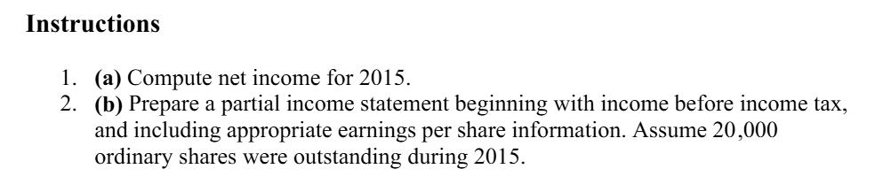
Problem
The following transactions relate to ABC & Co.
Jan. 1 | Sold Tk. 20,000 of merchandise to PC Co terms 2/10, N/30.
11 | Received payment in full from PC Co. for balance due.
13 | Accepted JC. Co.'s Tk. 20,000; 6 month, 12% note for balance due.
14 | Made ABC and Co. credit card sales for Tk. 13,200.
16 | Made American Express credit sales totaling Tk. 6,700. A 5% service fee is charged by American Express.
30 | Received payment in full from American Express Company.
Feb. 10 | Sold Account receivable of Tk. 8,000 to HF Co. assesses a service charge of 2% of the amount of receivable sold.
13 | Received collections of 8,200 on ABC Co. credit card sales and added finance charges of 1.5% to the remaining balances.
Mar. 10 | Write, off as uncollectible Tk. 16,000 of accounts receivable ABC & Co. uses percentage of sales basis to estimate bad debts.
31 | Credit sales for the first 3 months total Tk. 20, 00,000. The bad debt percentage is 1% on credit sales.
Apr. 10 | One of the accounts receivable written off in March was for Mr Samad who pays the amount due, Tk. 3,000 in full.
Required:
Prepare Journal entries for the transactions of ABC & Co.

Problem-17
The following transactions relate to Modern Stores:
March 1 | Sold Tk. 40,000 of merchandise on credit, term 2/10, n/30.
10 | Received payment in full of March 1 sales deducting discount.
12 | Accepted J. Company's Tk. 40,000, 6-month, 12% note for balance due.
13 | Made Modern Stores credit card sales Tk. 13,200.
15 | Made American Express credit card sales totaling Tk. 6,700. A 5% service charge fee is charged by American Express.
30 | Received payment in full from American Express.
April 11 | Sold accounts receivable of Tk. 20,000 to H. Company, H Company assesses a service charge of 2% of the amount of receivable sold.
13 | Received collection of Tk. 8.200 on Modern credit card sales and added finance charge of 1.5% to the remaining balance.
May 10 | Wrote off uncollectible Tk. 10,000 of accounts receivable. Modern Stores uses the percentage of credit sales basis to estimate bad debts.
June 30 | Credit sales for the 1st 6 months total Tk. 20,00,000. The bad debt percentage is 1% of credit sales.
July 16 | One of the accounts receivable written off in May Mr. X, who pays the amount due, Tk. 5,000 in full.
Instruction: | Prepare journal entries for the transactions of Modern Stores.

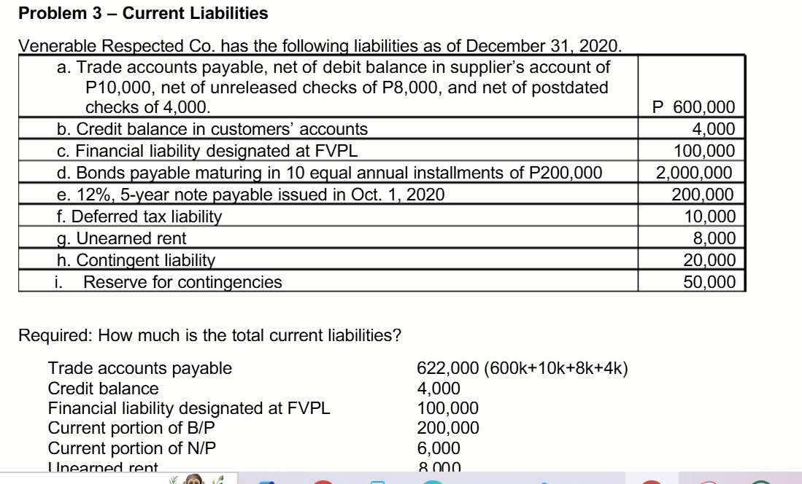
Problem 3 — Current Liabilities
Younger Online Company has the following liabilities as of December 31. 2020.
Jan. 1 | Trade accounts payable, net of debit balance in supplier's account of Tk.10, 000, net of unreleased checks of Tk.8, 000, and net of postdated checks of Tk.4, 000. | 529,000
Feb. 5 | Credit balance in customers' accounts | 4,000
Feb. 20 | Bonds payable maturing in 10 equal annual installments of Tk.100, 000. | 1,000,000
Oct. 1 | 12%, 5-year note payable issued in, 2020. | 200,000
Nov.1 | Unearned rent | 8,000
Nov.5 | Unearned Ticket Revenue | 10,000
Nov.10 | Warranty Liability | 8,000
Nov.15 | Interest Payable | 8,000
Dec. 20 | Sales Taxes Payable | 5,000
Required:
- Prepare journal entries to record the transactions related to Venerable Respected Co.
- Prepare the current liabilities section of the balance sheet.
- Comment on Younger Online Company's liquidity6, assuming total current assets are $900,000.

Younger Online Company
Journal Entries

Date | Particulars | Dr. | Cr.

b. Younger Online Company
Partial Balance Sheet
Particulars | Amount
Current Liabilities:
Trade accounts payable ( 529000+10, 000+8, 000+4, 000) | 5,51,000
Credit balance | 4,000
Current portion of B/P | 100,000
Current portion of N/P | 6000
Unearned rent | 8000
Unearned Ticket Revenue | 10,000
Warranty Liability | 8,000
Interest Payable | 8,000
Sales Taxes Payable | 5,000
Total current liabilities | 700,000

c.
The current assets =Tk.900,000
The Working Capital = Current assets - current liabilities = Tk.900,000 - Tk.700,000 = Tk. 2,00,000
Current ratio = Current assets: current liabilities = Tk.900,000: Tk.700,000 = 1.28:1

Historically, Companies and Analysts considered a current ratio of 2:1 to be the standard for the good credit rating. Younger Online Company is certainly below the standard of 2:1.

